H.T No
Regulations:
A18

Sreenidhi Institute of Science and Technology
(An Autonomous Institution)
Code No: 7A201 Date: 23-Nov-2020 (FN)

B.Tech I-Year II-Semester External Examination, Nov/Dec - 2020 (Regular & Supplementary)
ELECTRICAL CIRCUITS AND NETWORKS-I (EEE)

Time: 2 Hours Max.Marks:70

Note: a) No additional answer sheets will be provided.
b) All sub-parts of a question must be answered at one place only, otherwise it will not be valued.
c) Missing data can be assumed suitably.

ANSWER ANY 5 OUT OF 8 QUESTIONS. EACH QUESTION CARRIES 14 MARKS.

1. | a) | Write the voltage and current equations for R, L and C elements along with symbolic representations of elements. | [7M]
 | b) | State Kirchhoff’s voltage and current laws with an example to each. | [7M]
2. | a) | Define the following with an example  (i)Tree (ii) Graph (iii) Subgraph (iv)Cutest | [8M]
 | b) | For the network shown in figure, draw a tree. Write the cut set schedule and express the branch voltages in terms of the tree branch voltage.( Assume for any data) | [6M]
3. | a) | Define following:  (i) Leakage factor (ii)Magnetic flux density  (iii) Magnetic Fringing (iv) Coefficient of coupling. | [8M]
 | b) | Two similar coils are wound on a same core. The resistance of each coil is 10Ω. When excited by a 100V, 50Hz source, the first coil takes a current of 2A and the induced e.m.f in the second coil is 50V. Determine self and mutual inductances. | [6M]
4. | a) | Derive an expression for RMS and average value of sinusoidal function. | [7M]
 | b) | A circuit consists of series RC elements with R=15Ω and C=100μF. A sinusoidal voltage v(t)=100sin(500t + φ) volts is applied to the circuit at time corresponding to φ=45⁰ and the capacitor initially uncharged. Obtain the current in the circuit for t>0 | [7M]
5. | a) | Explain the procedure to draw the locus diagram of R-C series circuit when ‘C’ is varying. | [7M]
 | b) | Draw the locus diagram of R-L-C series circuit when varying X_{L} and X_{C} with neat explanation. | [7M]
6. | a) | Find the Thevenin’s equivalent circuit across 10Ω for the following figure. | [7M]
 | b) | State and prove Tellegen’s theorem with an example. | [7M]
7. | a) | Find currents in the following circuit using nodal analysis.  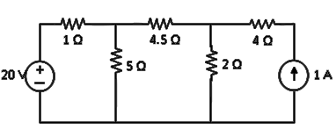 | [7M]
 | b) | Evaluate the currents i₁,i₂ and i₃ using mesh analysis for the following circuit.  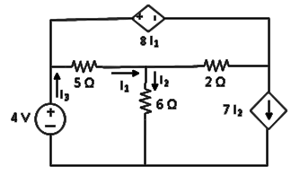 | [7M]
8. | a) | Mention properties of a graph and find the number of node pair voltage equations for network having 10 nodes and 17 branches. | [7M]
 | b) | Explain Duality and procedure for obtaining dual for the planar network with an example. | [7M]

-- 00 -- 00 –

